Team Beta!
Zach Peters, Shriya Krishnamurthy, Eric Poplavsky
Project Overview
Our bop-it is going to be the magic spellbook bop-it. Users will be asked to perform three distinct actions in a random order 99 times or until one of the actions is missed. The three actions are as follows:
- Learn It
- Charge It
- Cast It
Action (1) Learn it requires the user to flip a page of the spell book (hinged), and this can work in both directions (left and right). Any flip is valid in this case. It might make sense to use Hall sensors and a small magnet in the page to reach which side the page is on and flip back and forth. If time permits, we can add multiple pages and a sensing arrangement that identifies the active page. The book would read the initial page when a new game starts.

Action (2) requires the user to squeeze the base of the wand and will likely use a force sensor to read the input. We may also change this action to a touch feature using a capacitive touch sensor.

Action (3) “Cast It” requires the user to perform a deliberate wand gesture, measured by an accelerometer and gyroscope. The basic version would recognize one casting motion. If multiple spell pages are implemented, the detected gesture must match the spell shown on the active page. The book would record the required spell when the command begins, so changing pages during a casting attempt would count as an incorrect action. Gesture recognition could use a small, trained machine-learning model if time permits.

We can start the timer at 2 seconds and decrease by 14 msec every success.

Block Diagram
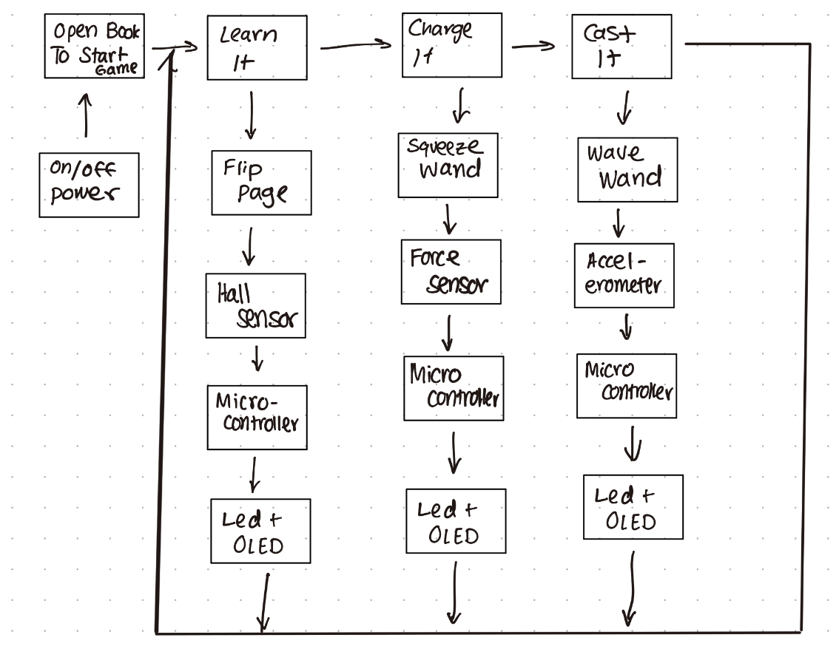
Pseudo Code for Microcontroller
main()
while (startbutton == false)
continue;
score = 0;
miss = false
time = 2
speedup = 0.01 # just an example
while (score < 99 and miss == false)
actions = 1;
for(int i = 0; i < actions; i++)
random_action_func(time)
if (miss == true)
break;
actions++
score++ if miss is false
time -= speedup
-----------------------------------------------------------------------------------
game_over_func();
-----------------------------------------------------------------------------------
bool random_action_func(time)
action = choose random action
# there should be a unique helper function for each action
bool miss = action_function(time);
return miss
----------------------------------------------------------------------------------
bool learn_func(time)
record current state of pages
wait time seconds
if interrupt (page state changes), return true
if other action detected, return false
return false
-----------------------------------------------------------------------------------
bool charge_func(time)
wait time seconds
if interrupt (button pressed), return true
if other action detected, return false
return false
------------------------------------------------------------------------------------
bool cast_func(time)
record accelerometer/IMU state
wait time seconds
if interrupt (accel > threshold or IMU state changes), return true
if other action detected, return false
return false
-----------------------------------------------------------------------------------
Extension:
At the start of a new game:
current_page = read_page_id()
active_spell = spell_for_page(current_page)

When Learn It succeeds:
current_page = detected_new_page
active_spell = spell_for_page(current_page)

When Cast It begins:
required_spell = active_spell
monitor inputs until the deadline
succeed if the detected gesture matches required_spell
fail if another action occurs or time runs out

Prelim Sketch of Enclosure
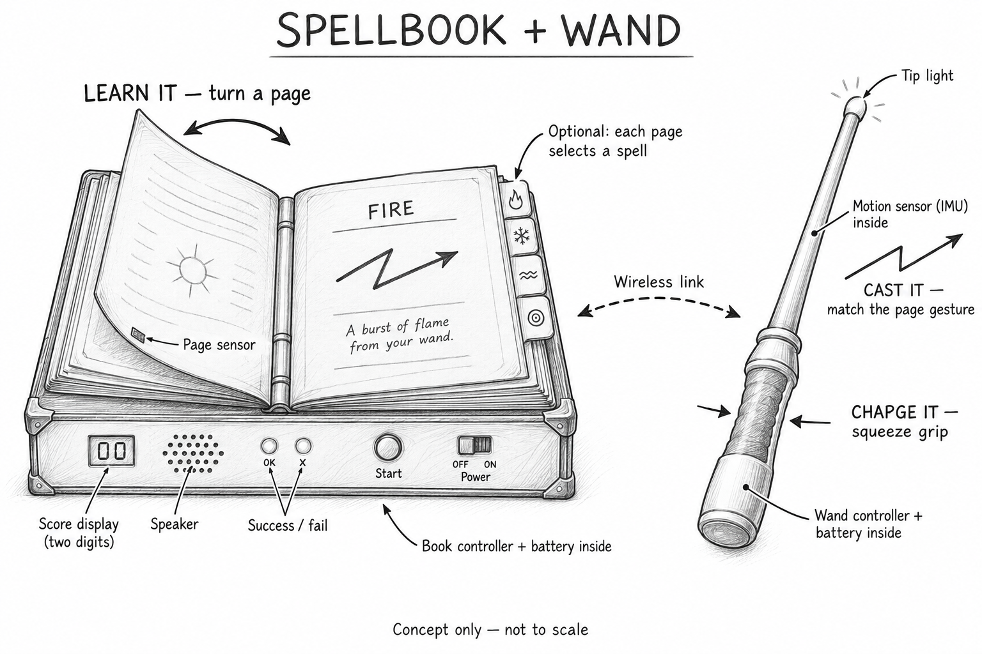

Team Roles
Electronics:
PCB: Shriya
Interfacing sensors, IMU, etc...: Shriya
Software:
State Machine: Eric
Interrupt handler: Zach
Recognizing different wand patterns: Eric/Zach
-Compact ML model if we have time
Mechanical:
CAD/Enclosure: Zach
Assembly: Eric
Aesthetic Design: Shriya
Prelim BOM
DigiKey
2 × Seeed XIAO ESP32S3 controllers — 1597-113991114-ND - microcontroller
4 x 7-PIN MALE HEADER FOR XIAO 5PACK — 102010490 – header 4 micro
10 x SPLICE LEVER 24-12AWG 2POS — 221-412 - splicing wires
4 x MAGNET 0.250"D X 0.063"THICK CYL— 8195 - magnets
2 × DFRobot DFR1132 analog Hall-effect sensors — 1738-DFR1132-ND
1 × DFPlayer Mini audio module — 1738-1041-ND
1 × DFRobot FIT0502 8-ohm enclosed speaker — 1738-FIT0502-ND
1 × Adafruit AT42QT1010 capacitive touch sensor, PID 1374 — 1528-1782-ND – maybe charge action (backup)
1 × Adafruit rotary encoder and knob, PID 377 — 1528-2438-ND - tune it action (backup)
1 × Adafruit VL53L1X distance sensor, PID 3967 — 1528-3967-ND – spell with hand action (backup)
1 × Adafruit flex sensor, PID 1070 — 1528-1070AD-ND – flex sensing for charge
SparkFun
4 × 0.125-inch cube magnets — COM-08644
1 × TMAG5273 3D Hall-effect sensor board — SEN-23880
Adafruit
1 x MPM3610 5V Buck Converter Breakout - 21V In 5V Out at 1.2A – PID 4739
1 × LSM6DSOX accelerometer and gyroscope — PID 4438
2 × Round force-sensitive resistors, 0.3–10 N — PID 166
1 × Round high-force resistor, 1–100 N — PID 5475
1 × Square force-sensitive resistor — PID 1075
3 × Roller-lever microswitches — PID 819
3 × Magnetic contact switch and magnet kits — PID 375
1 × 0.96-inch 128 × 64 OLED display — PID 326
1 × MAX98357A I2S audio amplifier — PID 3006
1 × Pack of 20 tactile pushbuttons — PID 367
1 × Switched JST-PH battery connector breakout — PID 1863
2 × SPDT slide switches — PID 805
1 × MCP23017 GPIO expander — PID 5346

PCB Component Ideas
- On the Book
  - ATMega
  - Bluetooth Module
  - DFPlayer + Speaker Connector
  - OLED connector
  - LEDs
  - Start Button + Main Power
  - Page Sensors + Connectors
  - Battery + Regulator (maybe buck converter)
- On the Wand
  - ATMega
  - Bluetooth Module
  - Accelerometer/Gyroscope (IMU?)
  - Force Sensor (FSR) (includes voltage divider)
  - Power switch + battery + regulator
  - LEDs
Need to define PCB outline based on enclosure
Should figure out pin map ASAP

